Last Edited On: 06/01/2018

**Purpose:** To provide instructions and tips/tricks on printing the components used to construct the miniport canisters used in Laura Duvall’s (The Rockefeller University, NYC) behavioral assays.

**Necessary Supplies**

**1. Clear** Cast Acrylic Sheets

* The cast acrylic sheets used in the Vosshall laboratory are typically ordered from the company McMaster-Carr. The 12” x 24” sheets are commonly ordered, though sheet length and width will depend on the size and formatting of the pieces you are cutting as well as the capacity of the laser cutter you are using. This company provides sheet thickness in inches, whereas laser cutting and manipulation typically involves using thickness in millimeters. For example, 3 mm thick sheets are equivalent to 1/8’’. This conversion is not exact but rather based on practical industry standards described here: <http://www.edsebooks.com/paper/inchmetric.html>. If then you’d like to order a 12” x 24” x 1/8” clear cast acrylic sheet for printing, this would be it: <https://www.mcmaster.com/#8560K257>.
* **Note:** 2 sheets of 12”x24’x1/8” acrylic coupled with 1 sheet of 12”x24”x1/4” acrylic produce 4 complete miniports.

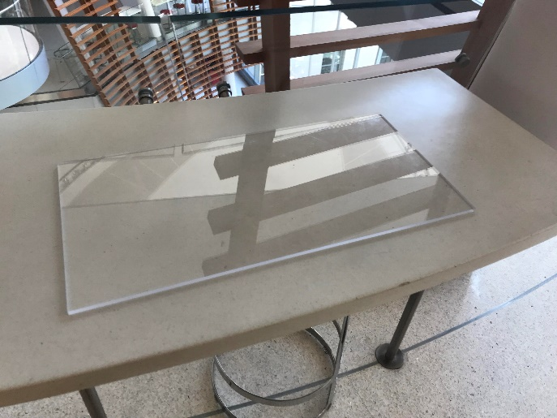

**2.** Acrylic Glue/Adhesive

* The most commonly effective adhesive glues used to piece together acrylic components are produced by the company SCIGRIP. Glue 4SC (Fast Set – Stock NO. 13417) and glue 3 (Very Fast Set – Stock NO. 10300) are typically used and can be ordered in various volumes. 1 pint is often more than enough for your gluing needs. Here’s an example of the fast set glue: <https://www.ebay.com/i/151110635733?chn=ps>. Small brushes and 200 uL pipettes are the most common applicators.

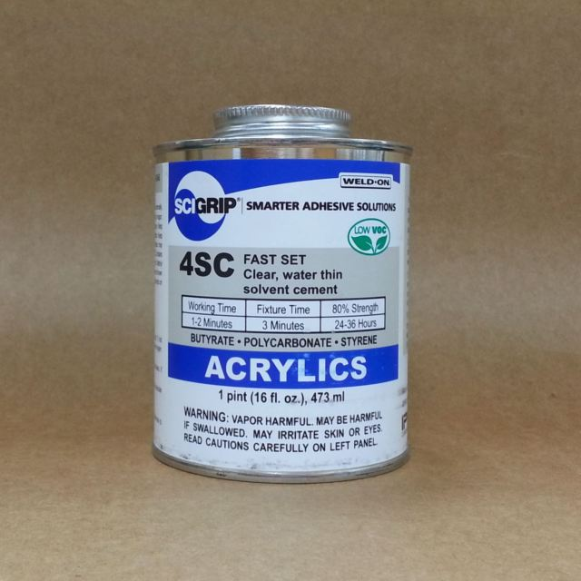

**3.** Mesh (cross-hatched)

* Silver mesh (not to be confused with chicken wire) is found in the Vosshall Lab supply closet that houses pans, buckets, CO2 tanks, etc. It can be ordered from a variety of vendors.

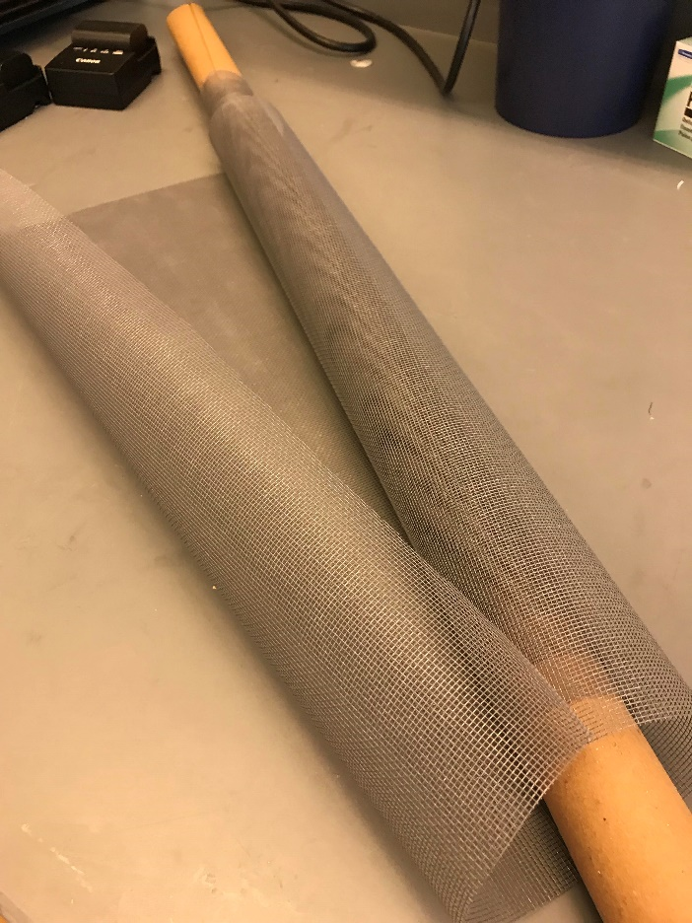

**4.** Box Cutters

* Box cutters can be found in various locations of the lab. A public lab one is located at the back administrative desk across from Barbara’s office.

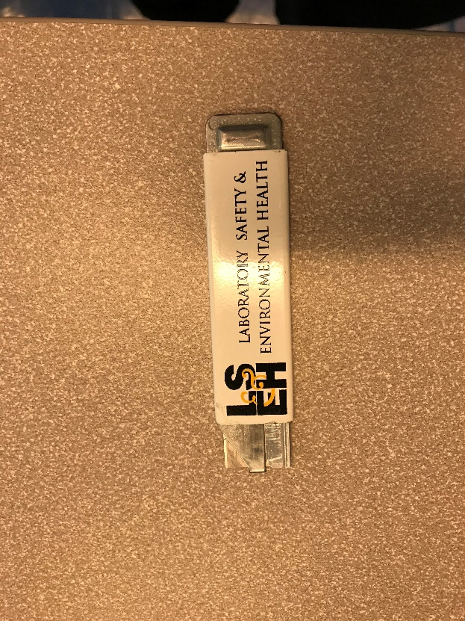

**Instructions for Building Miniports**

**Note 1**: The instructions below describe a protocol for building miniports by assembling one major component at a time. One should wait 10 minutes for the acrylic glue to set before assembling major components together to produce the complete miniport.

**Note 2:** The miniport consists of pieces that are 3mm thick and pieces that are 6mm thick. In this set of instructions, the thickness of the pieces constituting each major component will be noted. Two adobe illustrator files are needed to produce 4 complete miniports, “**Miniport 3mm Components_FINAL**” and “**Miniport 6mm Components_FINAL**”. 2 sheets of 12”x24’x1/8” (3mm) acrylic coupled with 1 sheet of 12”x24”x1/4” (6mm) acrylic produce 4 complete miniports.

**Step 1.** Assemble the base of the miniport around the central piece containing 4 wedges that flush into the holes of the 4 pieces shown below (6 mm).





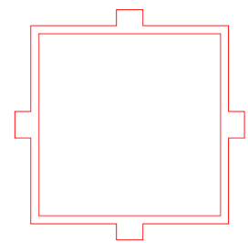

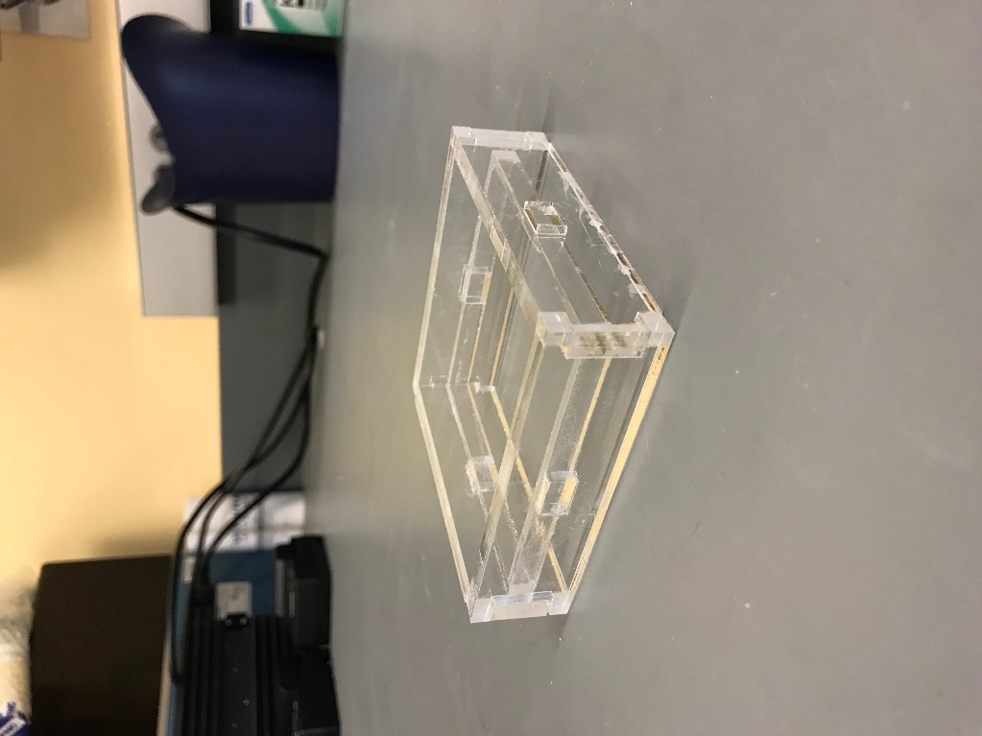

**Step 2.** Assemble the walls of the miniport by gluing together 4 of the identical walls shown below (3mm).

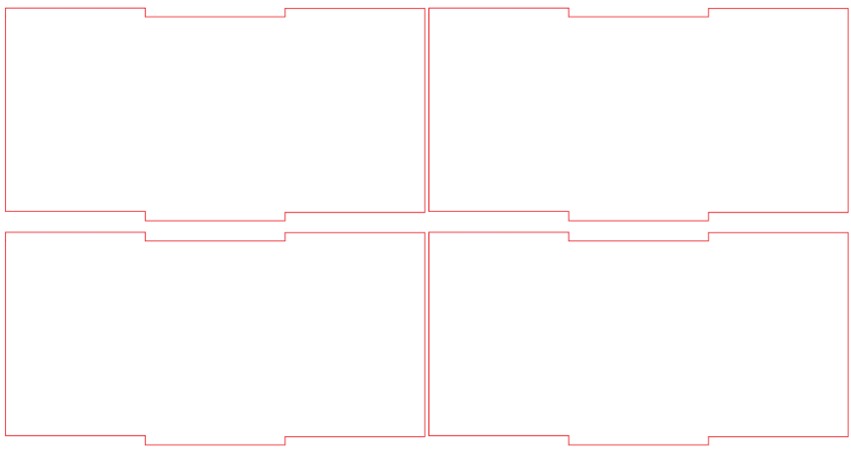

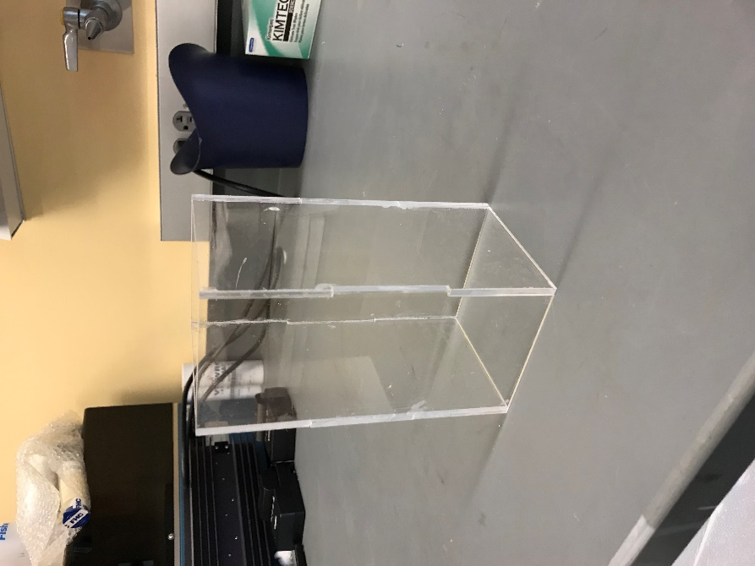 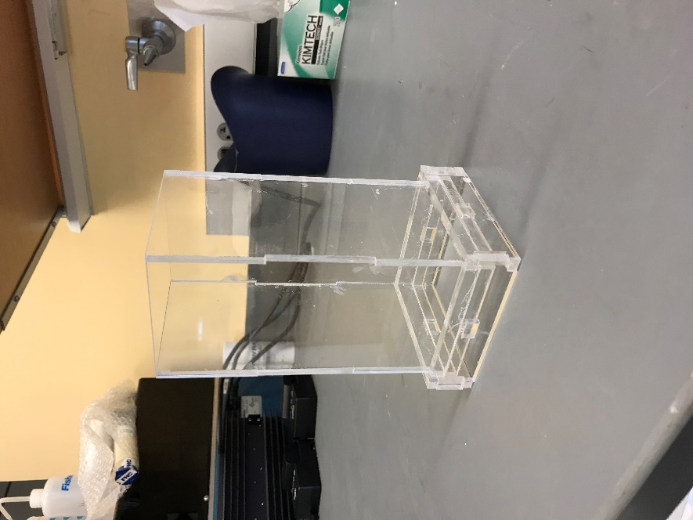

**Step 3.** Assemble the top of the miniport by assembling the 4 interlocking pieces shown below. Note that the black lines indicate where the laser cutter will etch into the acrylic. The technical term for this etching is “raster”, meaning the laser beam will repeatedly scan over the black region in order to remove a pre-programmed thickness. In the Vosshall Lab, we etched a thickness of 4mm – this works well, but depends on the capacity of your laser cutter. This allows the slider door of the miniport to slide smoothly. Be careful when gluing these pieces together, as the side that is etched needs to face the inside of the miniport, or else the slider door will not fit (6mm).

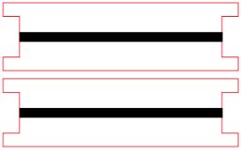 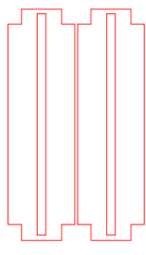

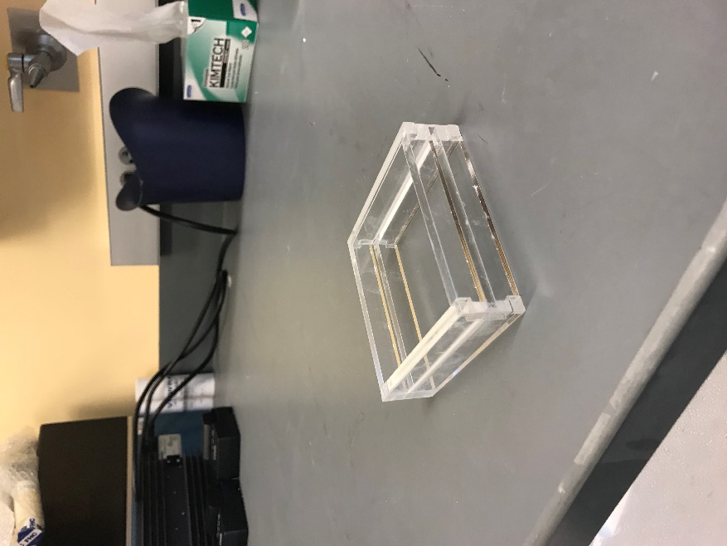  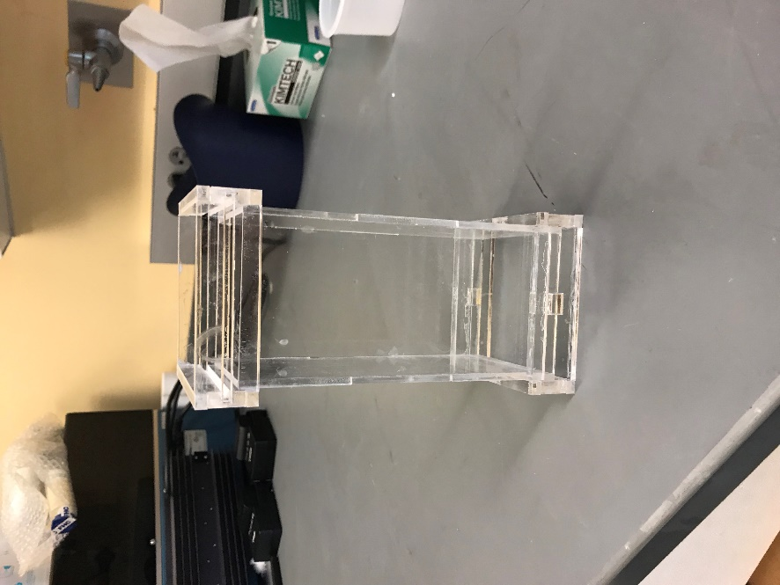

**Step 4.** Use a box cutter (example shown above) to cut out a piece of mesh that is slightly larger than the box shown below. Glue the mesh on the box first. After it is finished drying, glue the mesh-box complex into the bottom of the miniport. This prevents mosquitoes from flying out of the bottom of the miniport (3mm).



